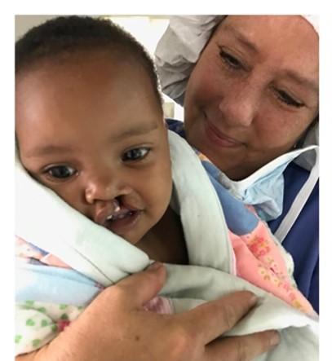
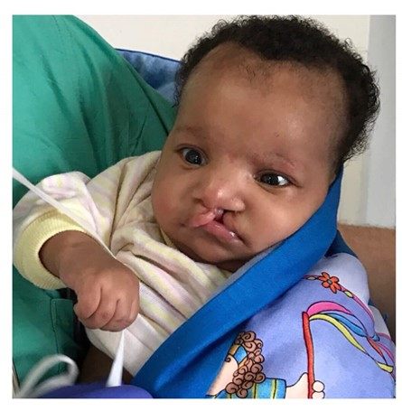
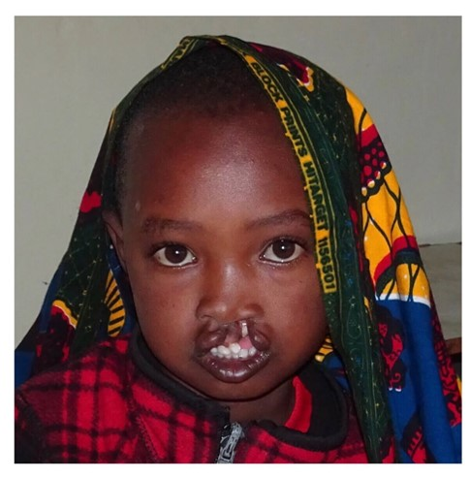

District 5300’s Rotaplast Mission to Arusha, Tanzania
Each year thousands of children are born with cleft lip and cleft palette anomalies. During the past seven years District 5300’s clubs and individuals generously raised the necessary funds for four medical missions, two to Retalhuleu, Guatemala, one to Monrovia, Liberia, and one to Lima Peru. 20 District Rotarians have volunteered their time to support the medical staff on these two week missions. Because of their efforts, individual contributions, and our clubs’ financial support, over 360 medical procedures were performed during our sponsored missions.
This year the presidents-elect of District 5300 decided to sponsor a fifth Rotaplast mission. From among the sites available, Governor-elect John Chase has selected to send a team to Arusha, Tanzania where significant needs remain related to cleft lip and palate surgeries and burn scars surgical repairs. The mission will take place on June 9-23, 2019.
Our mission will partner with local Rotary clubs which will provide the in-country support, publicize the mission in the surrounding communities, search out and find patients, and work side-by-side with our team to assure that patients’ needs are met. A full team typically consists of 22 medical and 8 non-medical volunteers.
We ask your support of this District-sponsored mission. Our goal is $60,000. We request that each club consider a contribution to this cause.
As in the past, we also welcome individual Rotarians’ donations to the mission. Pledge forms are on the District webpage under International Programs. Contributions should be made payable to ‘Rotary District 5300 Foundation” with “Rotaplast” clearly written on the memo line and then sent to Rotary International District 5300, P.O. Box 777908, Henderson, NV 89077. In order to upfront the expenses of the mission, we appreciate contributions be made by January 30, 2019; but we can be flexible.
Rotaplast International is a 501(c)(3) non-profit, humanitarian organization founded in 1992 as a world community service project of the Rotary Club of San Francisco by two Rotarians Dr. Angelo Capozzi and Peter Lagarias. Rotaplast is committed to changing lives through reconstructive surgery, and since that date has performed over 20,000 surgeries in 26 countries around the world, now averaging a dozen missions a year. It has received a 4 Star rating (the highest) by Charity Navigator.
QUESTIONS: Roger Schulte, rogerschulte@gmail.com 909-532-0673
Robin Smith, robin@smithteamlasvegas.com 702-460-5080

